TangerineSDR, DE to LH Communication Protocol, Version 3

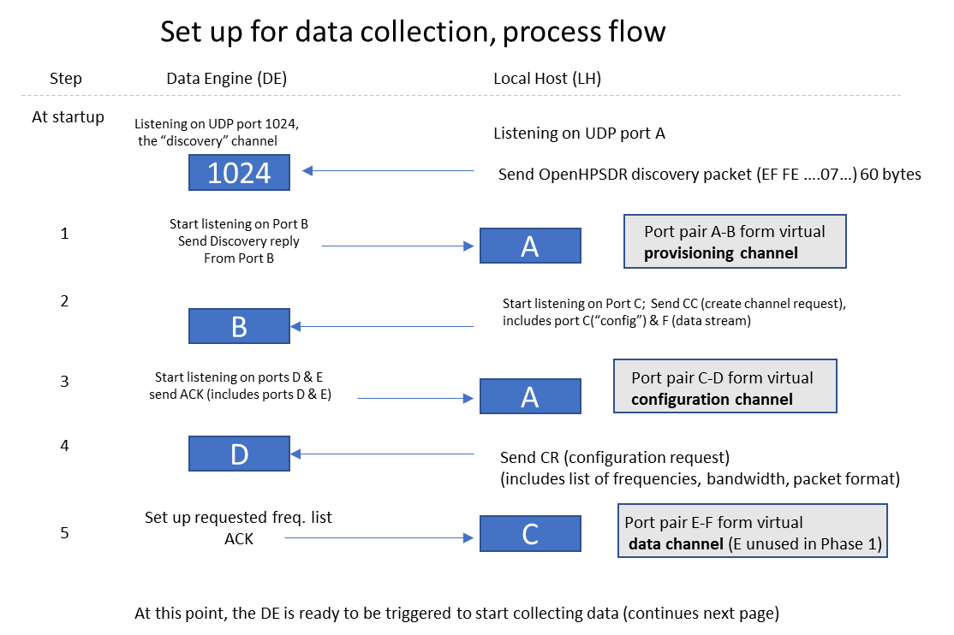

Figure 1.
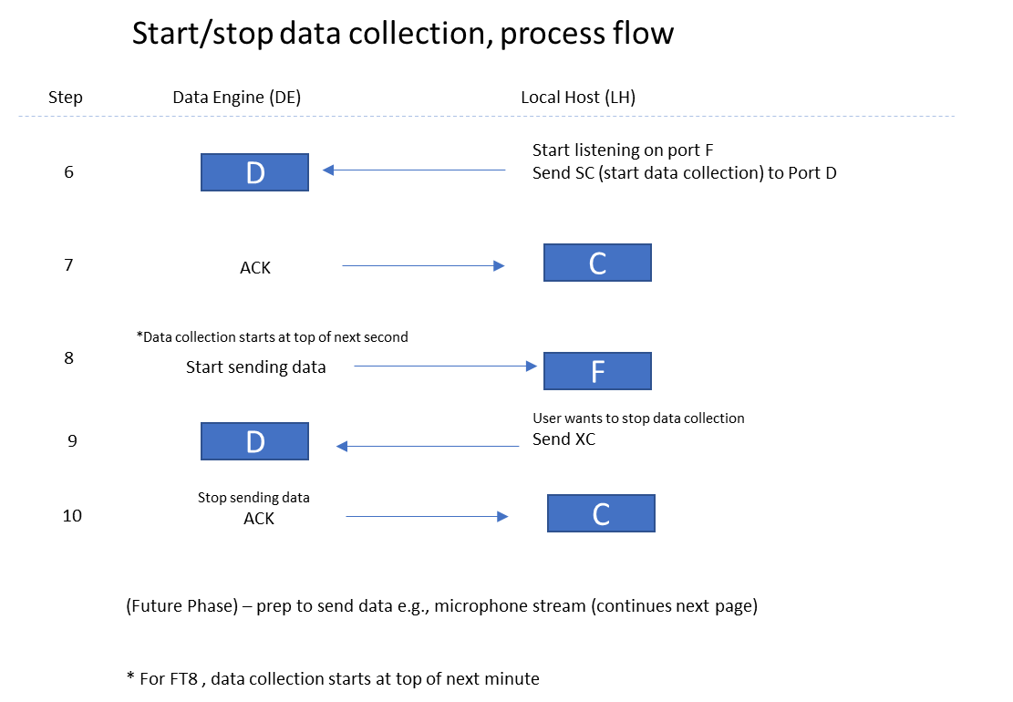

Figure 2.

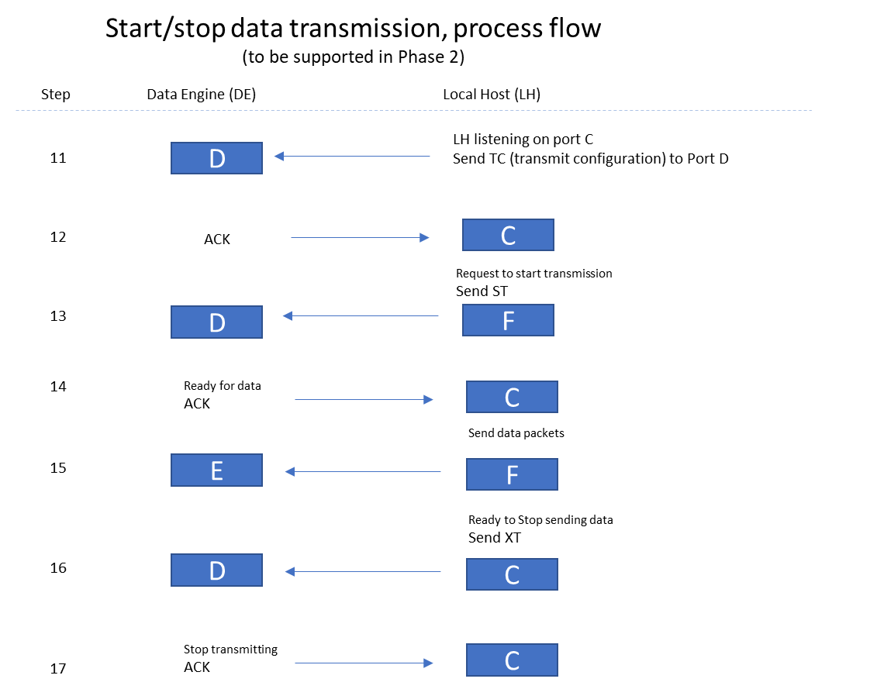

Figure 3.

Refer to narrative on following page.

Data Engine (DE) Local Host Communication Protocol (LH)
Setting up: see Figure 1.
At startup, the DE listens for UDP on port 1024. Steps for standard data collection (Ring Buffer) as follows.
- LH broadcasts a Discovery Packet (OpenHPSDR format starting with hex 0xEF 0xFE, with 0x07 in byte 7 identifying device as TangerineSDR). The DE is able to read the (randomly chosen) LH port from which this was sent, which we define as “Port A”. The DE randomly selects a port to listen on (“Port B”) for commands and sends a Discovery Reply to Port A. The LH reads Port B from the reply. This Port A – Port B pair forms the Provisioning Channel.
- The LH selects another port (“Port C”, which is in LH config.ini) and starts listening on that port. When ready to create the configuration channel pair, the LH sends the CC command (configuration channel create) to DE port B.
- The DE selects 2 more ports (Ports D and E). For Phase 1, only Port D will be used. The DE starts listening on Port D. Assuming this setup works, the DE sends an ACK packet (which includes Port D and E values) to LH Port A. Ports C and D now form the Configuration Channel.
- The LH sends a CR (configuration request to DE Port D). The CR packet includes a list of center frequencies and bandwidths (up to 16) and the desired packet format.
- The DE attempts to set up the requested frequency channels. If the DE is successful, it sends ACK to LH Port C. At this point, the port pair E-F form the Data Channel. If DE can’t satisfy request, it send NAK to LH Port C.
Starting/Stopping Data Collection: see Figure 2.
- When ready to start collecting data, the LH sends the SC command to DE Port D.
- The DE sends ACK to LH Port C.
- The DE waits until the exact top of the next second (for FT8, waits until the exact top of the next minute), then starts collecting/sending data to DE Port F. These UDP data packets have characteristics determined by the desired packet format requested in (4), above. One defined format will be type 0x00 (exact number TBD):
  - A header containing time stamp, magnetometer reading, plus anything else we decide
  - Exactly 1024 I-Q samples (each 32 bit floating point) with channels interleaved (regardless of the number of channels activated). Therefore the length of the packet will be the header length plus 8,192 bytes.
  - No ACKs are sent for data stream packets.
- When LH wants to stop data acquisition, it sends the XC command to DE Port D.
- DE sends ACK back to LH port C to acknowledge the stop command.

Starting/Stopping Data Transmission (Phase 2 and beyond): See Figure 3.
- LH sends a TC (“transmission configuration”) to DE Port D including the center frequency, packet format type, and data rate. The sets up a mic (or other) data stream.
- DE ACKs the stream setup command to LH port C.
- When ready to start transmitting, the LH sends ST command to DE port D.
- DE sends ACK to LH port C.
- LH streams UDP data to DE port E. (No ACKs sent for this). A watchdog timer will automatically stop transmission if time of transmission exceeds 5 minutes; in this case, a NAK is sent to LH.
- When ready to stop transmission, LH sends XT to DE Port D
- DE stops transmitting and sends ACK to LH port C

Error codes sent along with NAK
x0
- attempted to start receive (or transmit) of a mode without a valid configuration
- unsupported frequency requested
- unsupported mode requested
- unsupported data rate requested
- sum of requested data rates exceeds device capacity
- watchdog timeout: attempt to transmit for more than 5 minutes in a single transmission

Data Rate List
- LH sends 2-byte command: R?
- DE responds with a table of supported data rates (starting with 1)
- 32-bit integer rate number 32-bit integer rate (samples per second) for example:
  - 1 4000
  - 2 8000
  - 3 12000
  - 4 24000
  - 5 48000
  - 6 96000
  - 7 128000
  - 8 256000
- Channel configuration commands specify a data rate by selecting one of the rate numbers, e.g., to specify a channel data rate of 8000 samples per second, the rate number of 2 is included in the channel configuration request. Note that when multiple subchannels will be running, the same data rate will be used for all subchannels.
- The total data rate the DE is running at a given time is the number of running subchannels times the (single) data rate.
- If the user tries to specify a number of subchannels and data rate that multiplies out to a higher total data rate than the DE can support, the DE sends a NAK (NK) in response to the configuration request.

W. Engelke, AB4EJ, 27 APR 2020

