PERSONAL SPACE WEATHER SYSTEM

central control system

DETAILED DESIGN Specifications
Version Number: 0.0
Version Date: Aug. 26, 2019

General Comments from W2NAF:

- Stations can have multiple instruments, and not all instruments will be of the same type.
- We need the system to not only work with the Tangerine DataEngine, but also the low-cost PSWS version that CWRU will be developing, and stand-alone systems such as Ward’s stand-alone magnetometer implementation. This will probably require defining a standard, open API that the different developers can work with.
- This document seems to view most observations as a campaign-mode, or large-file bulk uploads. We need the system to have the ability to collect real-time, low-bandwidth streams of observations, too.
- We need to define a PI and institutionally reviewed data policy.

VERSION HISTORY

Version  Number | Implemented  By | Revision  Date | Approved  By | Approval  Date | Description of  Change
0.1 | W. Engelke | 8/19/2019

Contents
Contents 3
1. Introduction 4
2. Use Cases 5
2.1. About this section 5
2.2. UI Use Cases 5
2.2.1. USE CASE – User Welcome / Sign-Up /Sign-In Screen 5
2.2.2. USE CASE - Home Screen (user) 6
2.2.3. USE CASE: Station Configuration 8
2.2.4. USE CASE - Settings for Account 9
2.2.5. USE CASE - List of Stations 9
2.2.6. USE CASE – Data (Observations) 11
2.2.7. USE CASE - Create New Station 12
3. technical details 13
3.1. General 13
1. Logical Data Model 13
2. Requirements Traceability Matrix 13

Introduction
This Detailed Design Specification describes how the Local Host computer will be used (user interface, or UI), as well as its detailed internal design. It is organized into two parts:
- Use Cases, which illustrate the user’s experience, how the system will work behind the scenes to execute the user’s wishes, and processes
- Technical Details, which describe the technical approach, software tools, configurations, required software packages, interoperations, and interconnections required to carry out the required functionality.
Figure 1 shows an overview of the system architecture. This document is concerned with the detailed UI, operation, and technical considerations of the Central Control System.
Radio
(includes ADC, FPGA + DE)
Local Host (SBC)
Central Control System
Database Control
Internet
Personal Space Weather Station
(hundreds or thousands of these)
One central system
Tangerine

Figure 1. Conceptual Overview.

Use Cases

about this section
The Use Cases section starts with showing how the user will interact with the Central Control System through its web site and continues on to describe the automated features that operate on the Central Control System as background processes not directly viewable by the user.

UI Use Cases
This section describes User Interface uses cases, focusing on the user experience, with references to sections in Technical Details on notional approaches for how to implement the described functionality.

USE CASE – User Welcome / Sign-Up /Sign-In Screen
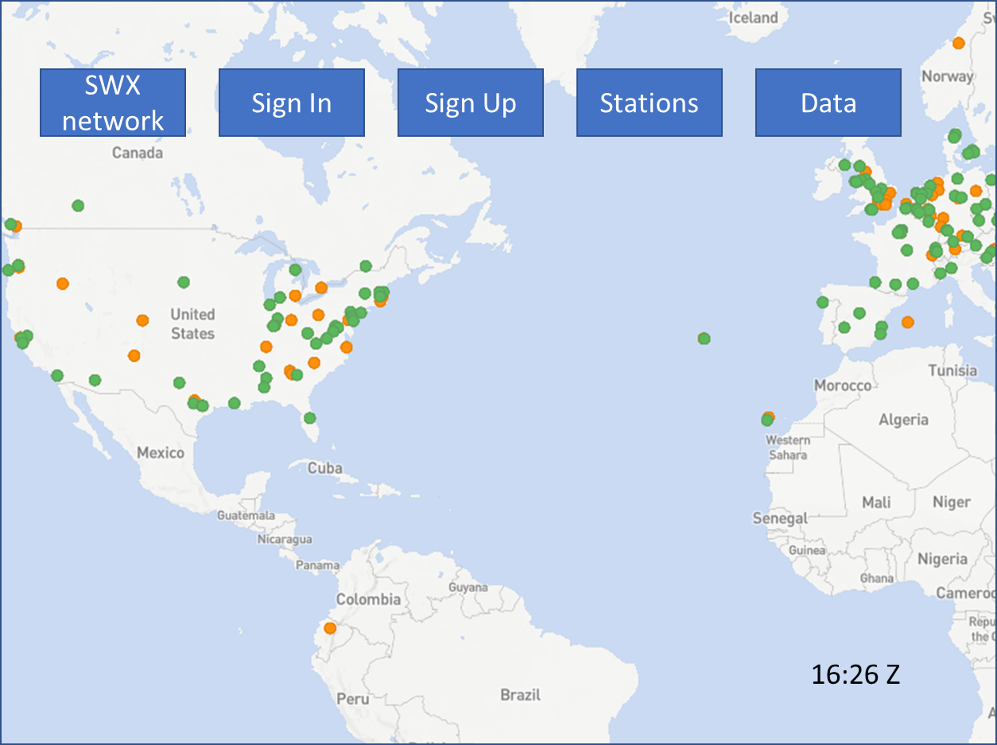

Figure 2. Welcome Screen.

Notes:
- The map in the background shows a world map with dots indicating PSWS stations; green to show online (Central Control received a heartbeat within the last 2 minutes), orange to show configured, but not receiving heartbeats. This is copied from SatNOGS design.
- Tentative design: note that this is derivative of the SatNOGS welcome screen; there may be some need to differentiate it. Necessary functions are shown; redesign the look if deemed appropriate.
- Most users will have a single station associated with their account, which will be initialized when the UID is created. “Power users” (e.g., most often institutions) may create additional stations. A station is associated with a single Tangerine.

Sign-In – (button/link) allows user to enter their user-ID (UID) and password; when successful, takes them to their User Home screen.
Sign Up – (button/link) allows user to enter a UID and requested password. If the verified UID already exists, or if the password does not meet minimum password standards, show the appropriate error. If the UID does not already exist, trigger a series of actions as follows:
- Create a new user account (if database entry already exists, link to the existing account record) – create one new station with unique station# (sequentially increasing from 1)
- Create a security token
- Send an email with a verification link to the supplied UID (email address)
- Mark account status as pending verification
- Optional: “I’m not a robot” captcha

Station(s): (button/link) go to List of Stations (see use case)

Data: (button/link) go to Data Page

About Us:

USE CASE - Home Screen (user)
Refer to figure below.

The Home Screen provides a variety of functions that let the user work with their account, settings, and data. It is the usual starting point after sign in. Items shown in italics are documentation comments, not something the user will see.

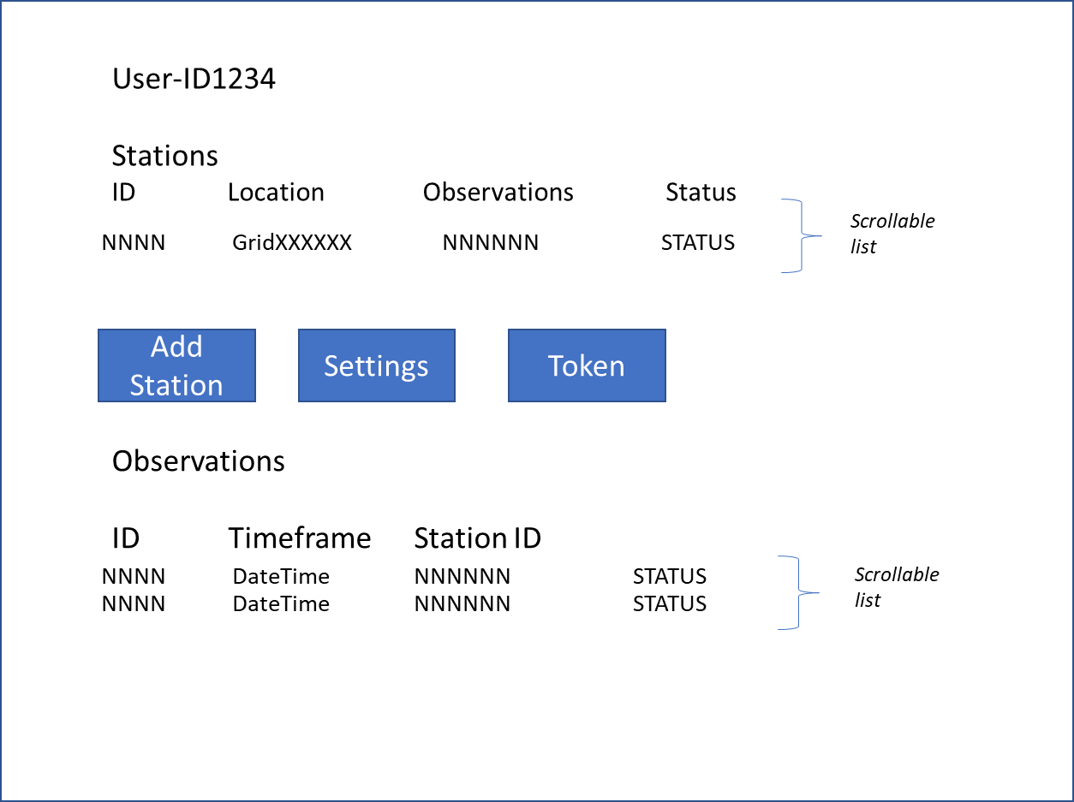
Figure 3. User Home Page.

Stations: List of Account’s stations – (scrollable list) shows the User’s PSWS Stations (each one a separate Tangerine). Most users will have only one. Each station in the list is clickable to take the user to the Station Configuration page that allows them to configure the characteristics of that station.
Add Station (button/link): takes user to web page allowing user to add a new station (see related Use Case) – when a user creates a new Account, one new station is automatically added. In those cases where a user will have more than one station under a single account, the user clicks here to go to that web page. NOTE: a given Tangerine (SDR) is allowed to be connected with one and only one Account-Station relationship, to avoid confusion in Central Host logic.
Settings (button/link): takes user to web page for making settings for this account; see related Use Case
Token (button/link) – displays the unique security key for this account. (Note that this token must be entered into each [Tangerine] station associated with this account).
Observations: (scrollable list) – list of uploading and uploaded observations; if an observation upload is in progress, this will be the topmost entry in this list; previous uploads are shown with descending DateTime.

USE CASE: Station Configuration
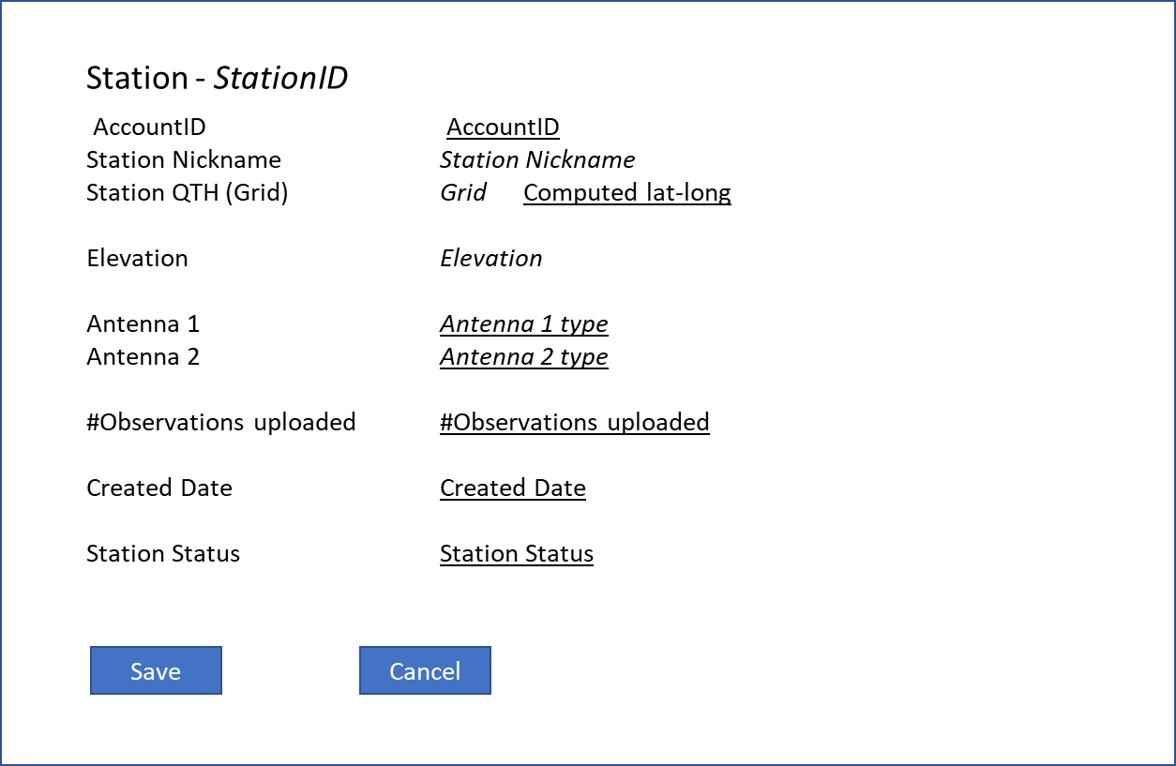
Figure 4. Station Configuration.

Refer figure above. Here, underlined denotes a value that the system computes (or looks up in database); italic denotes a value that the user can edit. Both italicized and underlined denotes that the user may select from a drop-down list.
Fields:
Station nickname – string – station name assigned by user
Account ID – account# with which this station is associated
Station QTH – the 6-character Maidenhead Grid Square where station is physically located
Elevation – station elevation in meters
Antenna 1/2 – antenna type (drop down list, values TBD ??)
#Observations Uploaded – number of observations successfully uploaded to Central Control from related station
Created Date – date the station was added
Station Status – Online (green) indicates heartbeat received within the last 2 minutes; offline (orange) otherwise
Save – Button – saves data
Cancel – Button – discards any changes

Display only case: if station configuration is viewed by anyone but the station owner, information is display only and cannot be edited.

USE CASE - Settings for Account

Refer to figure below.

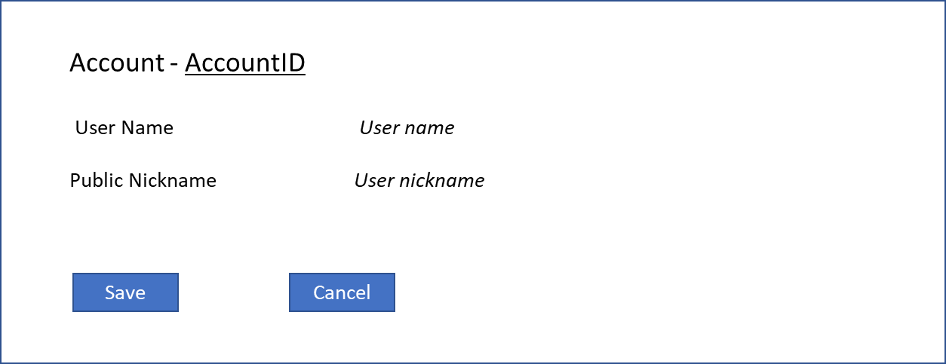
Figure 5. Settings for Account.

AccountID – account ID assigned at time of original account creation; from database.
User Name and Nickname – self explanatory, user choice.

USE CASE - List of Stations

This is a list of all PSWS stations in the system, filterable by status, location, antenna, and owner; with the list being sortable by any column.
ID – Station ID
Name – station name assigned by owner
Owner – nickname of station owner. If no nickname set, use name
Location – 6 character Maidenhead grid square assigned by user
Observation – number of observations successfully uploaded
Antennas – Antenna 1 type, Antenna 2 type (blank if only one antenna)
Status – Online: heartbeat received within last 2 minutes, otherwise Offline

If user clicks on a station, Station Configuration is displayed (see Use Case), but nothing is editable.

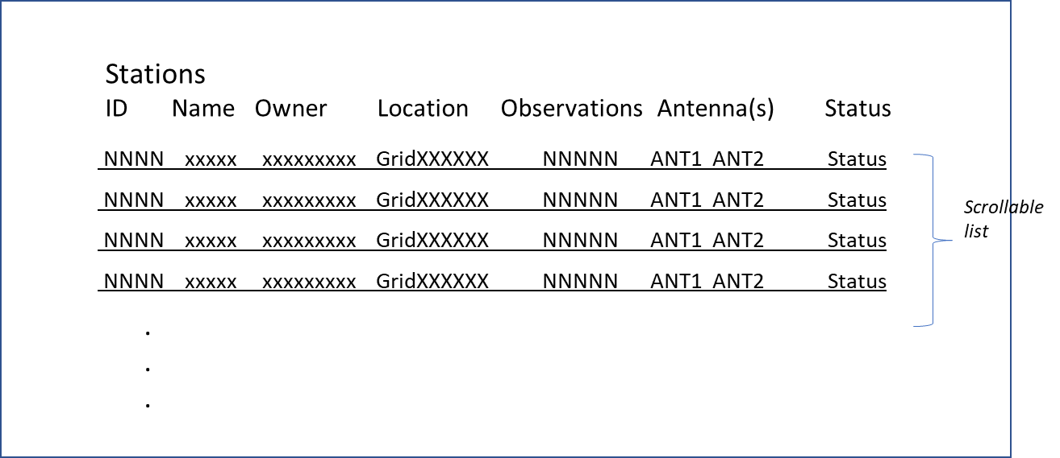
Figure 6. List of Stations.

USE CASE – Data (Observations)

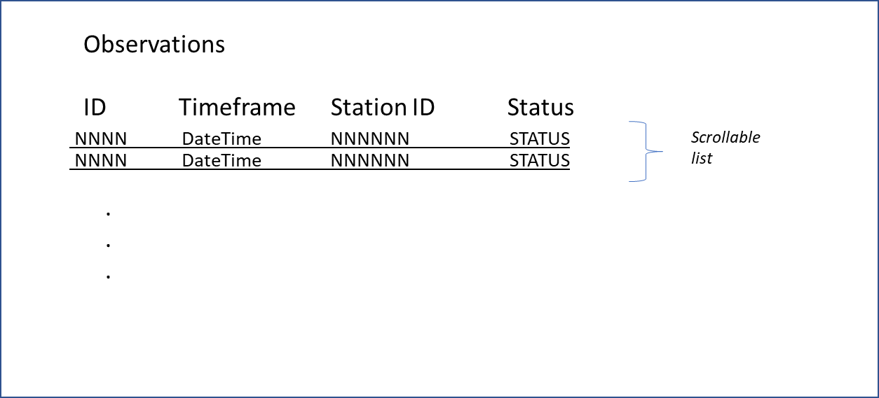
Figure 7. Data (observations).

Presents a list of successfully uploaded observations and uploads in progress (spectrum data in HDF5 format) which is scrollable and sortable by any column, containing:
ID – observation ID
Timeframe – start and end DateTime of observation
StationID – name of station which collected the data
Status – Uploaded, Uploading, Failed Upload

If user clicks on a line, a download dialog is shown which allows the user to select local location for the download, and to start the download. Note that many of these downloads will be very lengthy (hours) – need to be able to be restarted from point of failure

USE CASE - Create New Station

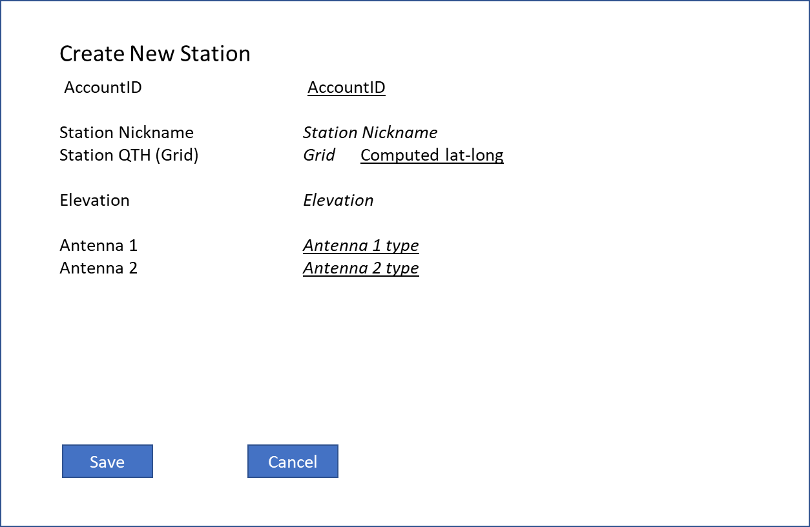
Figure 8. Create New Station.

When a user creates a new account, the system automatically creates a station for them. In the (many) cases where the account will be associated with only one station, the user will not need to use this function. It is for adding additional stations beyond the one default station.
Fields are the same as for Station Configuration; lat-long is not editable but is computed from Maidenhead Grid Square and is displayed. The entered Maidenhead Grid Square must be a valid, possible value; if user enters an invalid Grid Square (or none), display an error and prevent saving.
Elevation is in meters. If user enters no elevation, assume sea level.

technical details

General

Database Concepts TBD - ??
THIS SECTION TO BE FILLED IN NEXT

Logical Data Model
[Include the Logical Data Model as an appendix.]
See Appendix E - <Project Name> Logical Data Model.

Requirements Traceability Matrix
[Include the Traceability Matrix as an appendix. In the Requirements Analysis phase, the matrix is populated with requirements identified in the Requirements Definition. It is a living document that should be populated with information throughout design, construction, and test phases, etc.]
See Appendix F - <Project Name> Requirements Traceability Matrix.
- Appendix A: Functional Specifications Definition Approval
The undersigned acknowledge that they have reviewed the <Project Name> Requirements Definition and agree with the information presented within this document. Changes to this Requirements Definition will be coordinated with, and approved by, the undersigned, or their designated representatives.
[List the individuals whose signatures are desired. Examples of such individuals are Business Owner, Project Manager (if identified), and any appropriate stakeholders. Add additional lines for signature as necessary.]

Signature: |  | Date:
Print Name:
Title:
Role:

Signature: |  | Date:
Print Name:
Title:
Role:

Signature: |  | Date:
Print Name:
Title:
Role:

APPENDIX B: REFERENCES

The following table summarizes the documents referenced in this document.

Document Name | Description | Location
Tangerine SDR Requirements V0.3.pdf | System requirements | https://tangerinesdr.com/TangerineSDR_documents/

APPENDIX C: Business Process Model
The Business Process Model is attached as a separate document. (Master Flow diagram to be included and/or flow charts from EFOTM).

APPENDIX D: Logical Data Model
The Logical Data Model is attached as a separate document.

APPENDIX E: Requirements Traceability Matrix
The Requirements Traceability Matrix is attached as a separate document. (Refer to following spreadsheets):
- Combined Use Case List for Intervention Release 1-8-10.xls
- MCA - Intervention Business Requirements and Rules 12-29-09.xls

